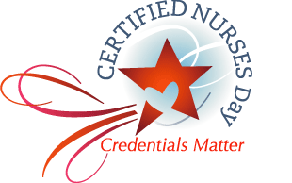
Sample Press Release for Certified Nurses Day

Press Release
{Date}
For Immediate Release

{Name of Facility} Celebrates Certified Nurses Day on March 19 By Honoring the {# of certified nurses} Board Certified Nurses on its Staff

{Facility Name} is celebrating Certified Nurses Day, on March 19, by honoring its board-certified nurses. The following nurses are being recognized for their professionalism, leadership, and commitment to excellence in patient care:

{Nurse Name # 1} {Specialty Certification(s)}
{Nurse Name # 2} {Specialty Certification(s)}
(and so forth)

Board Certification of nurses plays an increasingly important role in the assurance of high standards of care for patients and their loved ones. Nursing, like health care in general has become increasingly complex. While a registered nurse (RN) license provides entry to general nursing practice, the knowledge-intensive requirements of modern nursing require extensive education, as well as a strong personal commitment to excellence by the nurse.

{Name of facility} encourages national board certification for all its nurses. Patients are encouraged to inquire whether there are certified nurses on staff when they visit a hospital or their primary care provider. There are many nursing certification specialties such as medical-surgical, pediatric, pain management, cardiac vascular, oncology, hospice, case management, emergency nursing, critical care and many others. Many nursing certification bodies exist to serve the full range of specialized nursing care offered in the contemporary health care system; national nurse-certifying bodies should be accredited by the Accreditation Board for Specialty Nursing Certification (ABSNC) or the National Organization for Competence Assurance (NOCA).

Please join {Name of facility} and the nation’s national nursing certification organizations in honoring those hardworking, dedicated nurses for their professionalism, and a job well done!

