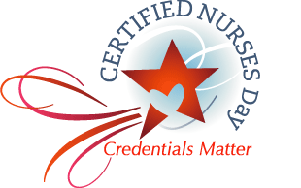Sample Recognition Letter to Nurse

Dear {Name of Nurse}:

I would like to take the opportunity of Certified Nurses Day, which is celebrated on March 19th, to express the gratitude and esteem that I and the management of {name of facility} feel for your professionalism and leadership in achieving and maintaining national board certification in your nursing specialty.

Board certification is a key factor in the assurance of minimum standards of knowledge, skills and abilities in nursing specialty practice and contributes to better patient outcomes. National certification allows nurses to be recognized for competence in their specialty. Thank you {name of nurse} for allowing us this opportunity to recognize yours.

*Optional* items and recognition ideas to include in letter (if applicable):

1. We have placed your name on the {name of facility} honor list, displayed in {location in building}.

2. We have placed an advertisement in the {name of local newspaper} recognizing you and your colleagues that are certified.

3. We hope you will take the attached {gift certificate; chocolate; bonus, specialty certification pin or other significant item} as a token of our recognition, appreciation and respect for your professionalism, our way of saying thank you.

4. I would like to take this opportunity to invite you to a {luncheon, tea, banquet, VIP reception with management, etc.} where we will join you in celebrating Certified Nurses Day.

We appreciate what you do to help us continue our growth as health care providers and to always build our skills together to contribute to higher standards of care and better patient outcomes.

With my sincere thanks and regards,

{CNO or other signer’s name}
Chief Nursing Officer

